Assignment 5

1. **CREATE A CALCULATOR WITH PROPER UI .**

**HTML :-**

<html></html>

<head>

    <title>Calculator</title>

    <link href="https://cdn.jsdelivr.net/npm/bootstrap@5.3.3/dist/css/bootstrap.min.css" rel="stylesheet" integrity="sha384-QWTKZyjpPEjISv5WaRU9OFeRpok6YctnYmDr5pNlyT2bRjXh0JMhjY6hW+ALEwIH" crossorigin="anonymous">

    <script src="https://cdn.jsdelivr.net/npm/bootstrap@5.3.3/dist/js/bootstrap.bundle.min.js" integrity="sha384-YvpcrYf0tY3lHB60NNkmXc5s9fDVZLESaAA55NDzOxhy9GkcIdslK1eN7N6jIeHz" crossorigin="anonymous"></script>

    <script>

        function Display(x) {

            let show=document.getElementById('display');

            show.value=show.value+x;

        }

    </script>

    <script>

        function Result(){

            let show=document.getElementById('display');

            try{

                show.value=eval(display.value)

            }

            catch{

                show.value="Error"

            }

        }

    </script>

</head>

<body>

<a target="_blank" href="https://c.tenor.com/wRP9JDw2sdkAAAAC/tenor.gif" style="color: #9c5d9c; margin-top: 100px; margin-left: 1200px">See Magic</a>

<center>

    <div style="margin-top: 10px;height: 400px;width: 350px;background-color: #404042; border-radius: 15px">

        <input id="display" type="text" style="width: 300px; height: 40px; margin-top: 30px; border-radius: 6px" readonly> <br>

        <button class="me-4" onclick="Display('7')" style="margin-top: 30px; margin-left: 25px; height: 50px; width: 50px">7</button>

        <button class="me-4" onclick="Display('8')" style="margin-top: 10px; height: 50px; width: 50px">8</button>

        <button class="me-4" onclick="Display('9')" style="margin-top: 10px; height: 50px; width: 50px">9</button>

        <button class="me-4" onclick="Display('/')" style="margin-top: 10px; height: 50px; width: 50px; background-color: #4fbfb9">/</button> <br>

        <button class="me-4" onclick="Display('4')" style="margin-top: 10px; margin-left: 25px; height: 50px; width: 50px">4</button>

        <button class="me-4" onclick="Display('5')" style="margin-top: 10px; height: 50px; width: 50px">5</button>

        <button class="me-4" onclick="Display('6')" style="margin-top: 10px; height: 50px; width: 50px">6</button>

        <button class="me-4" onclick="Display('')" style="margin-top: 10px; height: 50px; width: 50px; background-color: #4fbfb9"></button> <br>

        <button class="me-4" onclick="Display('1')" style="margin-top: 10px; margin-left: 25px; height: 50px; width: 50px">1</button>

        <button class="me-4" onclick="Display('2')" style="margin-top: 10px; height: 50px; width: 50px">2</button>

        <button class="me-4" onclick="Display('3')" style="margin-top: 10px; height: 50px; width: 50px">3</button>

        <button class="me-4" onclick="Display('-')" style="margin-top: 10px; height: 50px; width: 50px; background-color: #4fbfb9">-</button> <br>

        <button class="me-4" onclick="Display('0')" style="margin-top: 10px; margin-left: 25px; height: 50px; width: 50px">0</button>

        <button class="me-4" onclick="Display('.')" style="margin-top: 10px; height: 50px; width: 50px">.</button>

        <button class="me-4" onclick="Result()" style="margin-top: 10px; height: 50px; width: 50px; background-color: red">=</button>

        <button class="me-4" onclick="Display('+')" style="margin-top: 10px; height: 50px; width: 50px; background-color: #4fbfb9">+</button>

    </div>

    <p style="margin-top: 10px"> Press F5 To Clear Display </p>

</center>

</body>

</html>

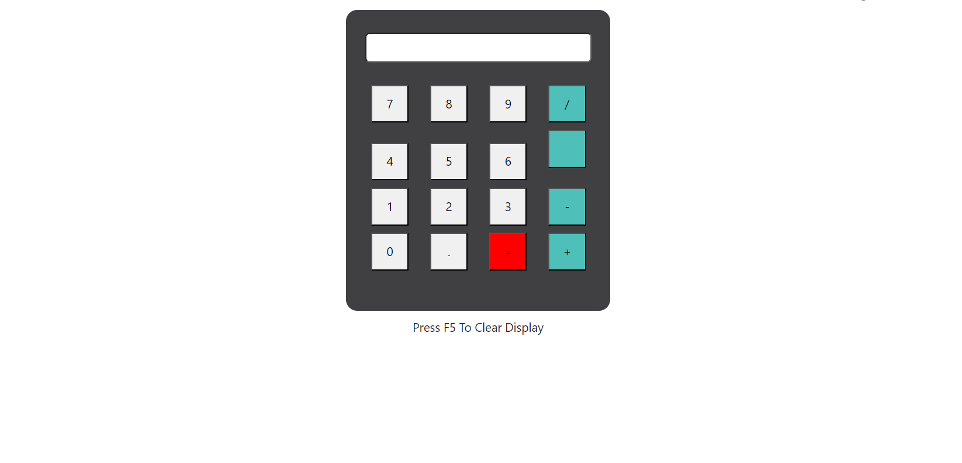**OUTPUT:-**